Digital Marketing Outline

To help you learn more about digital marketing strategies, you will be creating a fictitious company and product or service that you will market to your target audience with various methods throughout this course and the future courses in the Digital Marketing Assistant Program.
Complete the segments and answer the questions below to describe your company, product, marketing strategies and website design. Some segments you will complete as a part of an assignment and will add at that time. You will revise and update this document periodically to meet the changing needs of your company.

PART 1
(Complete During Week 1 of the Course)

Company Overview
Company Name: (Also add your company name to the main title on this page to replace the “Your Company Name” placeholder.)
ZAP ZAP: The company is a company that is based in the service and beauty industry. The company is focusing on the online marketing of the services provided. The company will be located in various neighborhoods in Florida, US. It will focus on niche that has the millennia and women.

Your Company Typography Logo
After completing the assignment in Week 3, add an image of your company typography logo below:

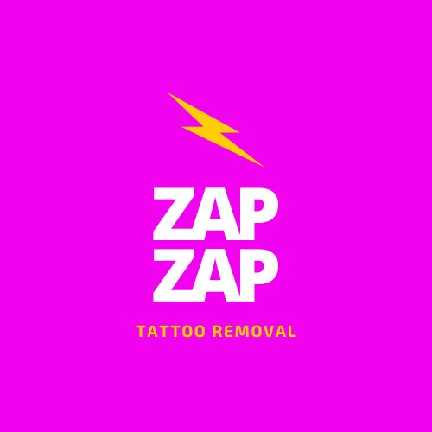

Product or service provided by your company:
Laser tattoo removal: The company is specialized in removing a tattoo that has been permanently instilled in different parts of the body. ZAP ZAP company provides tattoo removal services without pain and with very minimal damage to the skin. The firm focuses on differentiating the services from the other companies. Technology is a significant element, that the company applies to acquire soothing service outcomes for the customers.

Description of Product/Service:
The company’s services and products include Medspa that only specializes in laser tattoo removal. The technology does not affect any biological structure or body tissues. It can be applied for tattoo removal in any part of the body. The Medspa only removes tattoos from the human body without any reasonable damage.

Product Service Differentiation:
What makes your product different or unique from your competitors? What solution does your product/service offer? Why is your product/service valuable to your target audience?
The company tattoos’ removal services use Medspa as a new special laser technology without pain and customer cannot feel the action on the body. It is safe than the other methods that most firms apply to their clients. The value of Medspa laser services is that it does not affect human normal feelings during tattoo removal. It takes the shortest time possible to remove tattoos from the body using Medspa at an affordable price. Therefore, Medspa does not affect the body quality during the services.

Target Audience
Target Audience Considerations:
Why is your product/service valuable to your target audience? Why does this audience need your product?
The reason for using the Medspa laser is that it is valuable for women and their opinion changes over time. They also get regrettable tattoos and they require tattoo removal services most of the time. The women who are at age of 20 feel better when getting this service because they don’t experience pain during the tattoo removal process. The targeted audience is therefore women under 20 years. The women require this service frequently.
Your Persona:
After completing the assignment in Week 1, add an image of your final persona below:

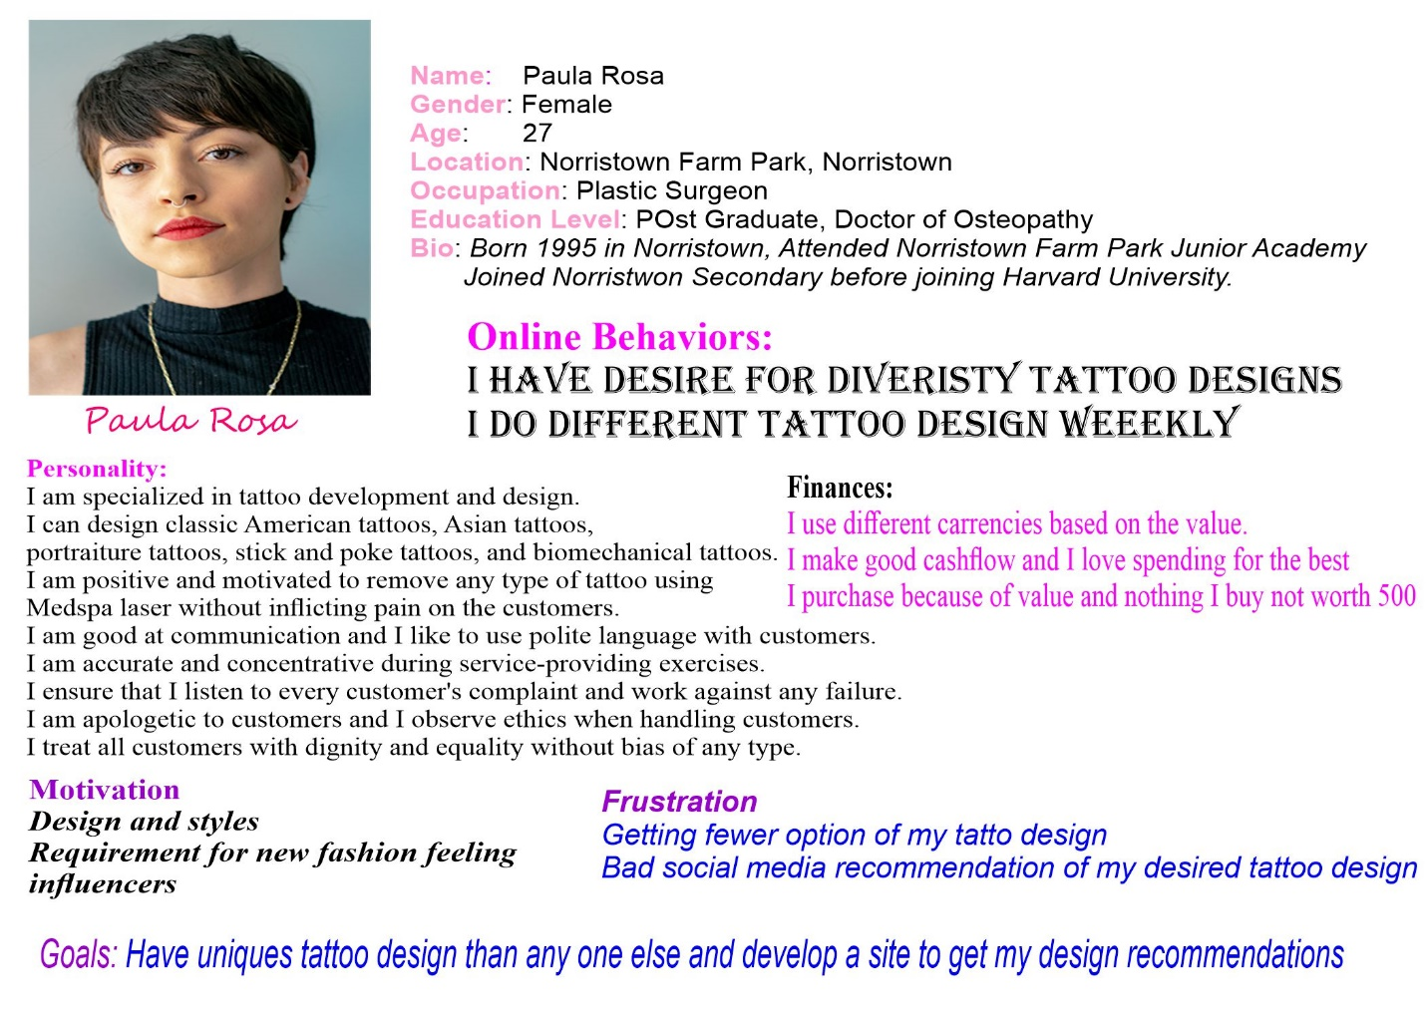
Digital Marketing Strategies
Digital Marketing Media Methods:
What digital marketing media will you use to interact with your target audience or ICA? How will you increase customer engagement about your product or service?
Digital Media Method | (How will you use this method to market our product or service?)
Website | will be used to showcase the tattoo removal service and bring in customers, info on service providers, the owner, and service/laser technology.
Social Media | showing pictures and text information to entice the customer visually since a lot of women in their 20s are on social media.
Online video | Demonstrate the customers under service provision
Blogging | to get media exposure.
Webinars | Demonstrate the work of Medspa laser
Images | showing before and after pictures to show results of happy satisfied customers.
Infographics | showing how many women are unhappy with regrettable tattoos and how they are even happier than before after the laser service. (percentages).
Email marketing | using this for email/customer engagement with promotions/deals/membership.
Search Engine Marketing (SEM) | making sure the website and advertisement links are within the first two pages of Google.com so it’s easier to navigate and shows more importance of the company/service
Search Engine Optimization (SEO) | ^ same method for SEM ^
Other methods?
PART 2
(Complete During Week 3 of the Course)
Website Design
Purpose and Goals:
What is the purpose and the goals of the website?
The purpose of the ZAP ZAP website is to bring in more returning satisfied clients back. This aspect will expand the organizational market based on customer satisfaction as the competitive advantage. The service and products provided will ensure satisfy the customers’ needs at all levels. The method of the service provider will attract more customers in the future and develop ZAP ZAP’s market targets.
What essential information do you want your audience to see?
The essential information that the audience should see from the company’s work of service providers includes the testimonials (before and after photos) from the website. Social media hyperlinks that have reported about the return clients and services appreciation. The clients or audience should also see pricing and confirm that it is affordable based on the services provided. I also need the audience to see the contact information including email and cellphone numbers. The contact information will include the ZAP ZAP social media.

What is the title of your website?
The tittle of the website will be self-explanatory: ZAP ZAP LASER TATTOO REMOVAL

What is the domain name?
ZAP ZAP

What topics and pages will be included on your website?
Page Topic (Change the page titles to meet your selections.) | (Describe what content will be on the pages of your website)
Home | a gallery of testimonial photos, logo, attractive font and color scheme, social media hyperlinks.
About | about the owner and service providers and history of company/owner.
Product/ Services | laser tattoo removal.
Pricing | showing various types of tattoo removal packages and price sheet.
Contact | showing address, email, phone, social media hyperlinks.
Other pages?

What key adjectives would you use to describe the look and feel of your website?
The color scheme is feminine and minimalist. VERY PROFESSIONAL.

What colors and types of fonts will be used on your website?
pink, gold, black color scheme. modern font style that is legible.

Site Structure Map
After completing the assignment in Week 3, add an image of your site map below:

